Project 1

Carlos Ribadeneira

Invoice table structure

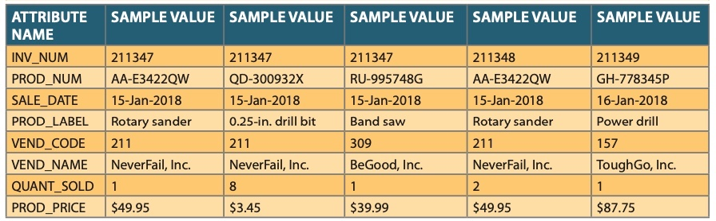

1. Relational schema and dependency diagram

INV_NUM (PK)

PROD_NUM (PK)

SALE_DATE

PROD_LABEL

VEND_CODE

VEND_NAME

QUANT_SOLD

PROD_PRICE

1NF (INV_NUM, PROD_NUM, SALE_DATE, PROD_LABEL, VEND_CODE, VEND_NAME, QUANT_SOLD, PROD_PRICE)

PARTIAL DEPENDENCY:

(IPROD_NUM 🡪 PROD_LABEL, PROD_PRICE, VEND_CODE, VEND, NAME)

TRANSITIVE DEPENDENCIES:

(PROD_LABEL 🡪 PROD_PRICE)

(VEND_CODE 🡪 VEND_NAME)

1. Remove all partial dependencies, write the relational schema, dependency diagram and identify the normal forms.

PRODUCT

PROD_NUM (PK)

PROD_LABEL

PROD_PRICE

VEND_CODE

VEND_NAME

INVOICE

SALE_DATE

INV_NUM (PK)

PROD_NUM (PK)

QUANT_SOLD

(2NF)

PRODUCT (IPROD_NUM, PROD_LABEL, PROD_PRICE, VEND_CODE, VEND, NAME)

INVOICE (INV_NUM, PROD_NUM, SALE_DATE, QUANT_SOLD)

TRANSITIVE DEPENDENCIES:

(PROD_LABEL 🡪 PROD_PRICE)

(VEND_CODE 🡪 VEND_NAME)

PRODUCT

|  |  |  |  |  |
| --- | --- | --- | --- | --- |
| PROD_NUM | PROD_LABEL | PROD_PRICE | VEND_CODE | VEND_NAME |
| AA-E3422QW | ROTARY SANDER | 49.95 | 211 | NeverFail, INC |
| QD-300932X | 0.25-IN. DRILL BIT | 3.45 | 211 | NeverFail, INC |
| RU-995748G | Band saw | 39.99 | 309 | BeGood, INC |
| AA-E3422QW | ROTARY SANDER | 49.95 | 211 | NeverFail, INC |
| GH-778345P | Power drill | 87.75 | 157 | ToughGo, INC |

INVOICE

|  |  |  |  |
| --- | --- | --- | --- |
| INV_NUM | PROD_NUM | SALE_DATE | QUANT_SOLD |
| 211347 | AA-E3422QW | 15-Jan-2018 | 1 |
| 211347 | QD-300932X | 15-Jan-2018 | 8 |
| 211347 | RU-995748G | 15-Jan-2018 | 1 |
| 211348 | AA-E3422QW | 15-Jan-2018 | 2 |
| 211349 | GH-778345P | 16-Jan-2018 | 1 |

1. Remove all transitive dependencies write the relational schema, dependency diagram and identify the normal forms.

PROUCT

PROD_NUM (PK)

PROD_LABEL

VEND_CODE

INVOICE

SALE_DATE

INV_NUM (PK)

PROD_NUM (PK)

QUANT_SOLD

VENDOR LABEL

PROD_LABEL

PROD_PRICE

VEND_CODE

VEND_NAME

(3NF)

PRODUCT (IPROD_NUM, PROD_LABEL, VEND_CODE)

INVOICE (INV_NUM, PROD_NUM, SALE_DATE, QUANT_SOLD)

VENDOR (VEND_CODE, VEND_NAME)

LABEL (PROD_LABEL, PROD_PRICE)

PRODUCT

|  |  |  |
| --- | --- | --- |
| PROD_NUM | PROD_LABEL | VEND_CODE |
| AA-E3422QW | ROTARY SANDER | 211 |
| QD-300932X | 0.25-IN. DRILL BIT | 211 |
| RU-995748G | Band saw | 309 |
| AA-E3422QW | ROTARY SANDER | 211 |
| GH-778345P | Power drill | 157 |

INVOICE

|  |  |  |  |
| --- | --- | --- | --- |
| INV_NUM | PROD_NUM | SALE_DATE | QUANT_SOLD |
| 211347 | AA-E3422QW | 15-Jan-2018 | 1 |
| 211347 | QD-300932X | 15-Jan-2018 | 8 |
| 211347 | RU-995748G | 15-Jan-2018 | 1 |
| 211348 | AA-E3422QW | 15-Jan-2018 | 2 |
| 211349 | GH-778345P | 16-Jan-2018 | 1 |

VENDOR

|  |  |
| --- | --- |
| VEND_CODE | VEND_NAME |
| 211 | NeverFail, INC |
| 211 | NeverFail, INC |
| 309 | BeGood, INC |
| 211 | NeverFail, INC |
| 157 | ToughGo, INC |

LABEL

|  |  |
| --- | --- |
| PROD_LABEL | PROD_PRICE |
| ROTARY SANDER | 49.95 |
| 0.25-IN. DRILL BIT | 3.45 |
| Band saw | 39.99 |
| ROTARY SANDER | 49.95 |
| Power drill | 87.75 |